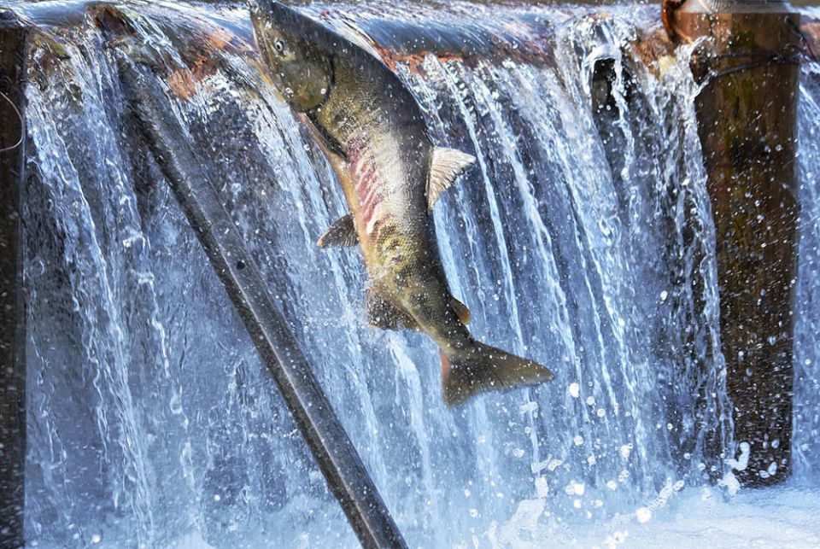
A fish tale: What I learned from the salmon
Aug 27, 2021 by Jennifer Wilson (a theology teacher and the diversity, inclusion and equity coordinator at a Catholic high school in Buffalo, New York, US)

The 12-pound fighter of a fish was pulled out of the water and squirmed around trying to get loose. I stood there looking at this salmon, unaware that during my month-long adventure in Alaska this scenario would repeat itself many times over.
My knowledge of salmon was limited before this. I knew the basics: They swim upriver, they are pink — at least the part that ends up on my dinner plate. Now back home in Buffalo after a month of encountering these fish, I am a self-proclaimed expert. If you want to know the particulars, I am happy to bore you with all the details.
There is one part of the lives of these fish that cannot go untold, and that is the swimming upriver part. Knowing that this happens and seeing it happen are two different things entirely. My first experience with actually seeing this was in Ketchikan, Alaska.
I stood there fascinated and somewhat bewildered as hundreds of fish tried to swim up a waterfall. It wasn't Niagara Falls, but it was still a lot of water — with a lot of fish doing what didn't seem possible. I was traveling with my dad, and I told him we had to go back and take another look. I had been thinking about it since I saw it, and I just couldn't wrap my mind around what I saw.
Of course, I had to consult Google, but even with that information detailing why these salmon go back to where they were born to spawn, I just could not understand it. On my second encounter I still stood there in awe once more. I seriously think if I lived there, I would go watch these salmon every day of the spawning season.
I don't always have to know the reason for everything or figure everything out. However — for whatever reason — I seem to need to know what the deal is with these fish. Why would they do such a thing?
Every time my dad caught one of these feisty fish from the ocean, I thought, well we saved you from a terrible fate. To my way of thinking, ending up on my dinner plate is a better fate than trying to swim up that waterfall! I watched these playful fish leap out of the water many times in the ocean. Every time I saw them, I had to wonder: Do they know they will soon be attempting a death-defying climb up a waterfall?
I was taking a break to try to shake off the burnout from being in the classroom during COVID-19. My monthlong trip to Alaska was wonderful — and obviously produced many random thoughts about salmon! Now back home my thoughts have turned to the upcoming school year. When the school year ended it seemed like COVID-19 might be somewhat behind us and that the uncertainty was over. However, that is not the case. It is not all gloom and doom though. We are fortunate to have access to a vaccine in this country. If we want it, we can get it.
Yet the approaching school year does turn my thoughts back to those salmon. I continue to keep wondering why those fish do such a thing. I know it is a call of Mother Nature; it is the way they are "wired" — but I still think it seems a bit crazy.
I am fortunate enough to have choices in my life. I don't have to teach this year; I could make another choice. I love teaching; though I have also been thinking about a change for a while, it is not part of my nature to leave when things get tough. Like those salmon, there is something in me that will keep going.
The approaching school year feels like I am attempting to do what those salmon did in swimming upstream. This pandemic has many children, teachers and administrators entering their third school year and facing the often numerous issues associated with COVID-19. We do not know what will happen in the future or when this pandemic might end. Unlike the salmon we have the ability to reflect, to trust in God and to lean on each other.
As I imagine the upcoming school year it is true that I think about the potential pitfalls that include a lot of uncertainty and the possibility of virtual learning. I also think about the smiles of the students I teach. I imagine the joy I feel when I see them connect what they are learning to something they saw or heard outside of school. I can almost hear my cross-country team complain at practice — teasing and having fun.
These are the possibilities; they lessen the feeling that I am swimming upstream. I have something those salmon do not. I have a community around me, I have my students and I have God. These people and my relationship with God are what keep me from drowning in what sometime feels like swimming upriver into the unknown.
Most of us have the people, the places, the relationships that make the upstream battle of COVID-19 easier. We are not just being driven to swim upstream, we are being invited to swim upstream with others. The invitation includes continuing to develop our relationship with God, to relish the little moments — no matter how small — and to nurture the creativity in us and in those closest to us.

