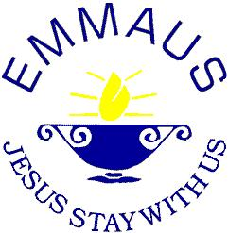
EMMAUS SCHOOL SYDENHAM
370 Sydenham Road, Sydenham Vic 3038
Phone: 9390 4500 Fax: 9390 1700

CREDIT CARD AUTHORISATION FORM
I Click or tap here to enter name. (please print name) authorise Emmaus School Sydenham to debit my

Credit Card, detailed below, with the sum $Click or tap here to enter amount. and to credit such sum to the following account.
The final payment will be adjusted to the final amount outstanding.

DEBTOR ACCOUNT NUMBER Click or tap here to enter text.

DEBTOR ACCOUNT NAME Click or tap here to enter text.

ELDEST STUDENT NAME Click or tap here to enter text.

TELEPHONE NUMBER Click or tap here to enter text.

Payment options Weekly Fortnightly Monthly Termly Yearly
☐ ☐ ☐ ☐ ☐
Commencing Date Click or tap to enter a date.
Until Click or tap to enter a date.

Cardholder Name On Card (please print) Click or tap here to enter text.

Card Number _ _ _ _/_ _ _ _/ _ _ _ _/ _ _ _ _

Card Expiry Date Click or tap to enter a date. CCV No (3 digits) Click or tap here to enter text.

Type of Card (please circle) Mastercard ☐ Visa ☐

Cardholder signature:Click or tap here to enter text. Date:Click or tap to enter a date.

(If your credit card is renewed in this period please contact the School on 9390 4500 with the new expiry date as soon as possible so that we are able to continue to process your payments.)

Please check your credit card statements to see that all payments have been processed

